How to Decrypt Office 365 Encrypted Email Procedure

Purpose
This procedure shows the steps to take when decrypting an Office 365 encrypted email.

Procedure
- Open the Lifeworks Encrypted message from your email and select “Read the message.”
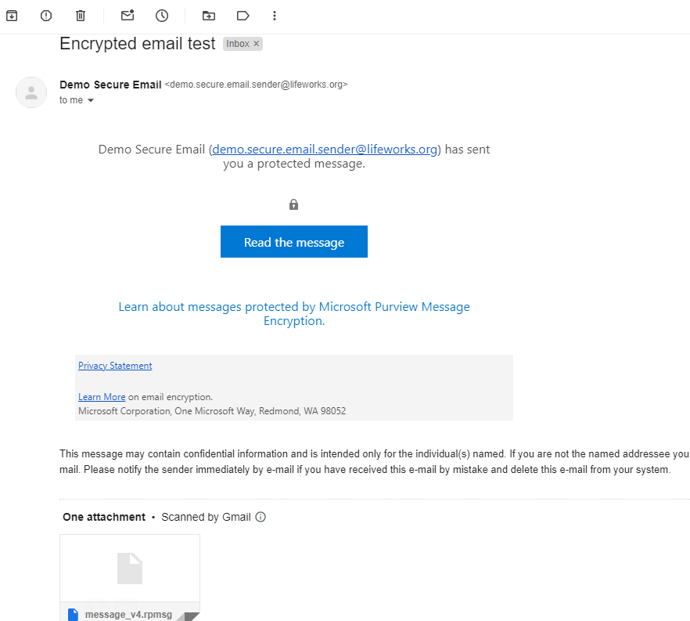
- When the message loads select “Sign in with a One-time passcode”
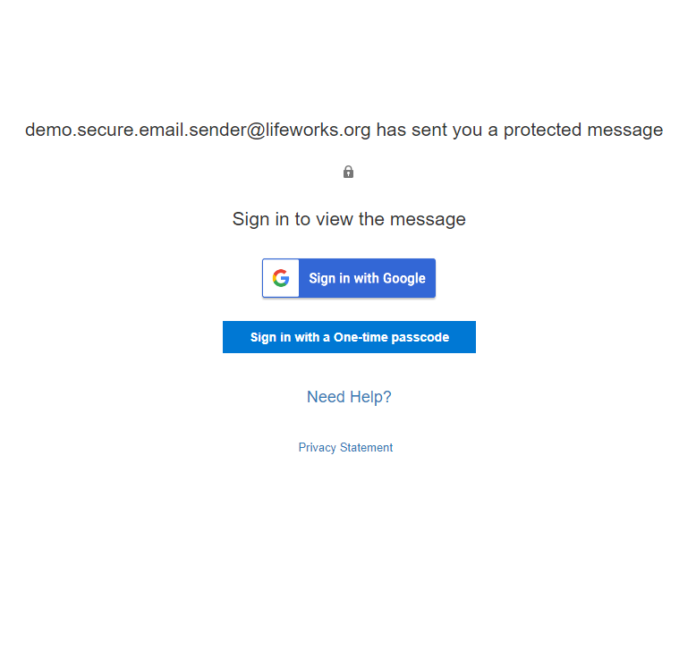

- You will receive a One-time passcode sent to your email. For example (the numbers will change each time),
  - The numbers shown below are just EXAMPLES. Do not use the numbers below for your One-time passcode.
  - You may need to open the link in another browser.
  - Be aware you may need to tell the link to open in another browser 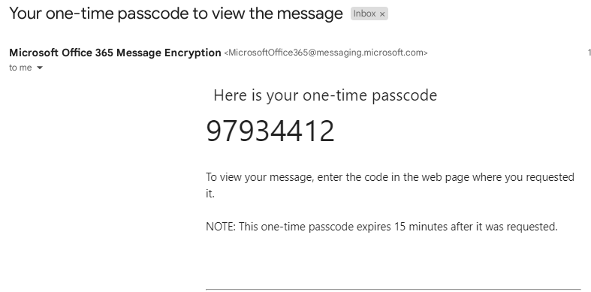

- Enter the passcode into the box provided:
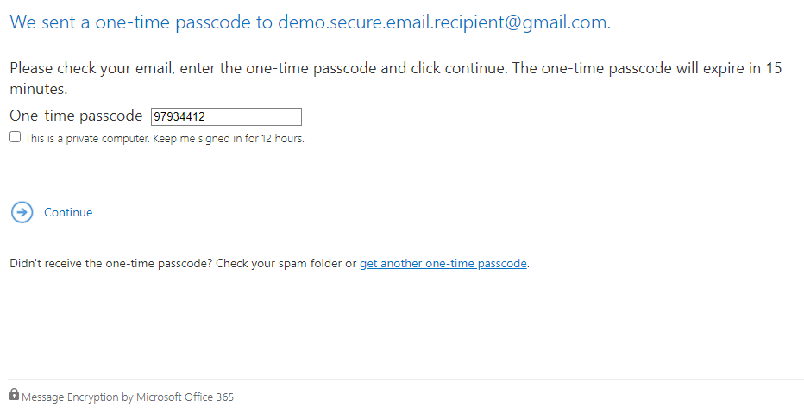

- Select continue once you enter the one-time passcode and your message will be displayed.

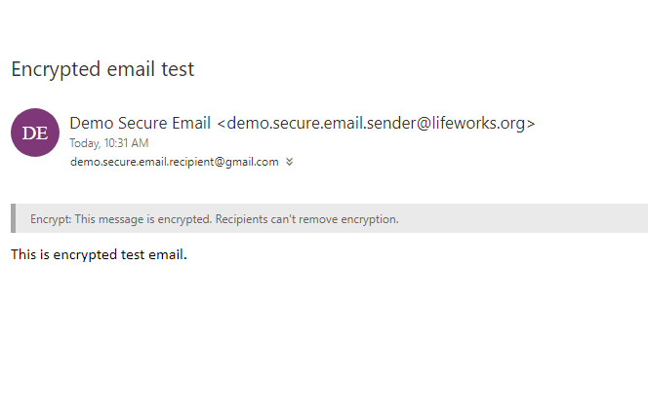
- If you need further assistance, reach out to the sender of the email.

