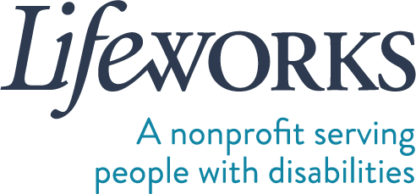

EMPLOYMENT PAPERWORK REQUEST FORM

Within 1 business day of receiving this form, Lifeworks will send the employee their employment paperwork via DocuSign email.

PARTICIPANT FIRST (LEGAL) NAME  Click or tap here to enter text. | PARTICIPANT LAST (LEGAL) NAME  Click or tap here to enter text.
PARTICIPANT PROGRAM - FMS
☐ CDCS ☐ CSG
PARTICIPANT PROGRAM – 245D Basic
☐ Respite ☐ Homemaker ☐ Individualized Home Support ☐ Night Supervision
PARTICIPANT PROGRAM - PCA
☐ PCA Choice
MANAGING PARTY LEGAL NAME (signer of the employee’s I9)
Click or tap here to enter text.
MANAGING PARTY EMAIL
Click or tap here to enter text.
EMPLOYEE FIRST (LEGAL) NAME  Click or tap here to enter text. | EMPLOYEE LAST (LEGAL) NAME  Click or tap here to enter text.
EMPLOYEE EMAIL
Click or tap here to enter text.
EMPLOYEE DATE OF BIRTH Age pertains to eligibility to work in specific programs
Click or tap to enter a date.

Please e-mail completed form to: GetHired@lifeworks.org, fax to: #651-454-2773, or drop it off at: 6636 Cedar Ave South, Suite 250, Richfield, MN 55423.

Please have employee reach out to Lifeworks at GetHired@lifeworks.org with questions pertaining to the employment paperwork process.

Thank you!

Fiscal HR Team
Lifeworks Services, Inc.
p: 651-454-2732 | f: 651-454-2773

LIFEWORKS SERVICES ∙ 6636 Cedar Ave South, Suite 250, Richfield, MN 55423 ∙ lifeworks.org Updated 5/11/2023

